

September 12, 2019

Dear HBChurch member,

Our church is successfully fulfilling our purpose: helping people grow spiritually as followers of Jesus Christ. We have more people attending our Bible Studies, Life Groups, Outreach events, prayer meetings, and worship services than we have in several years. And we are still working hard behind the scenes to expand our ministries with a high school and preschool ministry.

Most of what we do at Huntington Beach Church is accomplished by volunteers. I am not sure I have ever seen a church where so many people are active: serving and volunteering in every way possible to accomplish our goals. It is a sign of a healthy congregation!

We do have a couple of roles that need to be filled: one is a temporary volunteer position and one is a full-time salaried position.

1. **Accountant:** We need someone who has accounting skills to help our staff put together a budget for 2020. This task will require a couple of hours per week for about four weeks. It is a volunteer position. This person will join our budget committee and help our pastor develop a budget for next year and present it to our church council by November. The church council will finalize the budget and present it to the congregation for a vote in December.
2. **Preschool Administrator:** We need someone who would like to be our preschool administrator and help us launch our preschool. This person will need to pass state qualifications which includes having a few years of experience in teaching children or working in a preschool or daycare. This will be a salaried position. There will be some training and credentialing involved. We want to launch our preschool in the Fall of 2020 with at least 5 children.

Both of these positions will serve vital roles in the ongoing growth of ministry in our church. Are you gifted or skilled in one of these areas? Do you feel that God may be calling you to serve in His kingdom in one of these roles? These are great opportunities to make a real difference in our church and in our community. Both of these roles are essential in our efforts to fulfill the Great Commission!

Contact me by email or by phone if you would like to talk about these opportunities. If we do not fill these roles, our church will not be able to continue growing. So, please pray about it. Even if you are not the one God is calling to fulfill one of these roles, please pray for the person that God is calling.

Blessings,

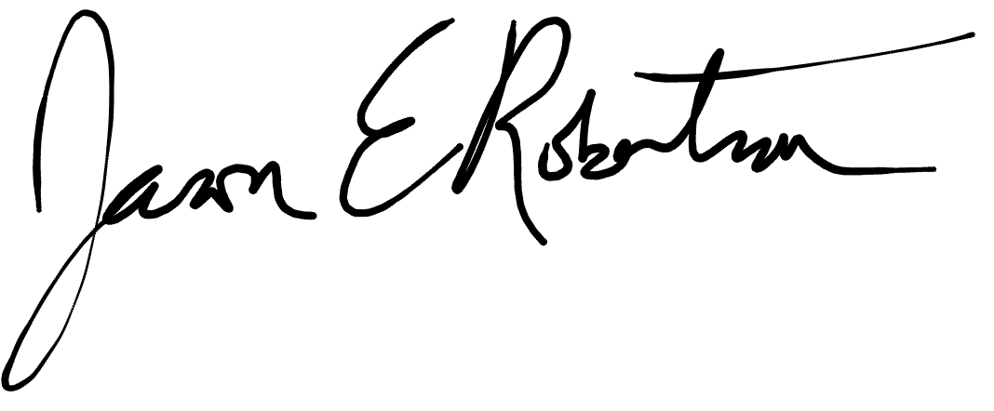

Jason Robertson

m. 951-440-6807

e. 44jason@gmail.com